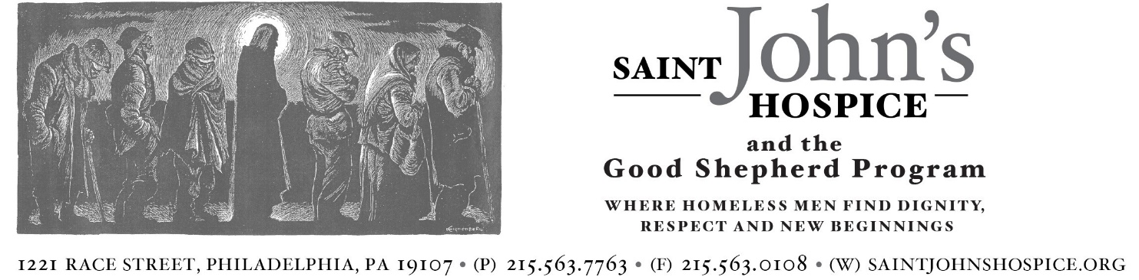

Date of Application: _____________________________
Volunteer Name: ______________________________________________________________________________________________
Mailing Address: ______________________________________________________________________________________________
City: ___________________________________________________ State: _______________ Zip: ___________________________
Phone: _______________________________________________ Email: _________________________________________________
How did you learn about our program? ____________________________________________________________________
Briefly describe why you are interested in volunteering at Saint John’s Hospice: ____________________________________________________________________________________________________________________________________________________________________________________________________________________________________
When are you available to volunteer your time? Check all that apply:
□ Monday □ Tuesday □ Wednesday □ Thursday □ Friday
What type of volunteer service are you interested in at Saint John’s Hospice? Check all that apply:
□ Noon time meal/lunch service (M-F) 11:00am-1:00pm
□ Evening meal service (MWF) 4:00pm-5:00pm
□ Front Desk Receptionist (M-F) 9:00am-12:00pm
□ Donation Organizer (M-F) 9:00am-12:00pm
□ Other (Please specify): ___________________________________________________________________________________
Are you CPR certified? □ Yes □ No Are you First Aid Training certified? □ Yes □ No
Are there any medical limitations on the type of volunteer work you can perform? □ Yes □ No
If yes, please specify: ________________________________________________________________________________________
Emergency Contact Name: __________________________________________________________________________________
Emergency Contact Phone: ______________________________________ Relationship: __________________________
Are you volunteering to fulfill a Community Service Requirement? _____________________________________
Are you employed? □ Yes □ No
If yes, name of employer: _______________________________________ Job Title: ________________________________
Employer’s Address: _________________________________________________________________________________________
Please provide 1 to 2 references (no relatives). If possible, please include references from a job, previous volunteer experience, or community activity. We may contact one or all three of your references.

- Name: __________________________________________ Relationship:______________________________________
Phone: ______________________________________________ Email: ______________________________________________
- Name: __________________________________________ Relationship:______________________________________
Phone: ______________________________________________ Email: ______________________________________________

I understand that Saint John’s Hospice staff will check the above references before I am accepted into the Volunteer Program. I also understand that certain volunteer placements require a State Criminal and/or Child Abuse History Clearance. I give permission to Saint John’s Hospice staff to check my references and send for any necessary clearances.

Applicant Signature: _________________________________________ Date: _____________________

Please return the completed form to:
Saint John’s Hospice
Attn: Liz Small
1221 Race Street
Philadelphia, PA 19107

Any questions? Please contact Liz Small, Director of Development at
esmall@chs-adphila.org or 215-756-2142

